PASSWORD STRENGTH AUDITING
This project was conducted in a controlled environment for educational purposes only.
INTRODUCTION:
The purpose of this lab was to perform a password strength audit to assess password strength and understand how default passwords can be the main access point for hackers. Password security is a fundamental line of defense for any account or organization’s security. It only allows the authorized users to access a system or device. This lab assessment was conducted using a controlled environment to explore the importance of strong passwords and how default passwords can be exploited in the real world.
LAB SETUP
The lab setup consisted of a virtualized environment on a NAT network containing Kali Linux and Metasploitable. The operating system of Kali Linux was used as the attacking device, and the target machine was Metasploitable 2. Furthermore, the tools utilized to perform this audit were:
Nmap | To discover ports and versions
SSH | To access Metasploitable
SCP | Transferring files
Unshadow | To merge the passwd and shadow files
RockYou | Real list of passwords, wordlist dictionary
John the Ripper | Crack the password

METHODOLOGY
Step 1: Find the IP address of the target machine
This assessment began with discovering the IP address of the target machine by running the command “ifconfig”.
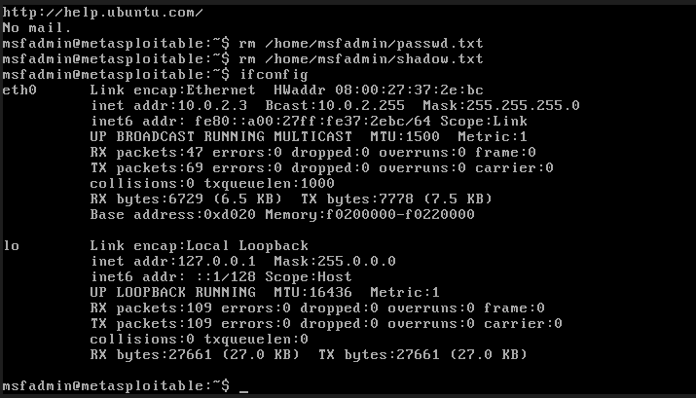
Figure 1: Find the IP address of the target
Step 2: Discover the open ports and services running
Then the command nmap -sV <target IP> was used to discover the ports opened and service versions running on the target device to identify the attack surface.
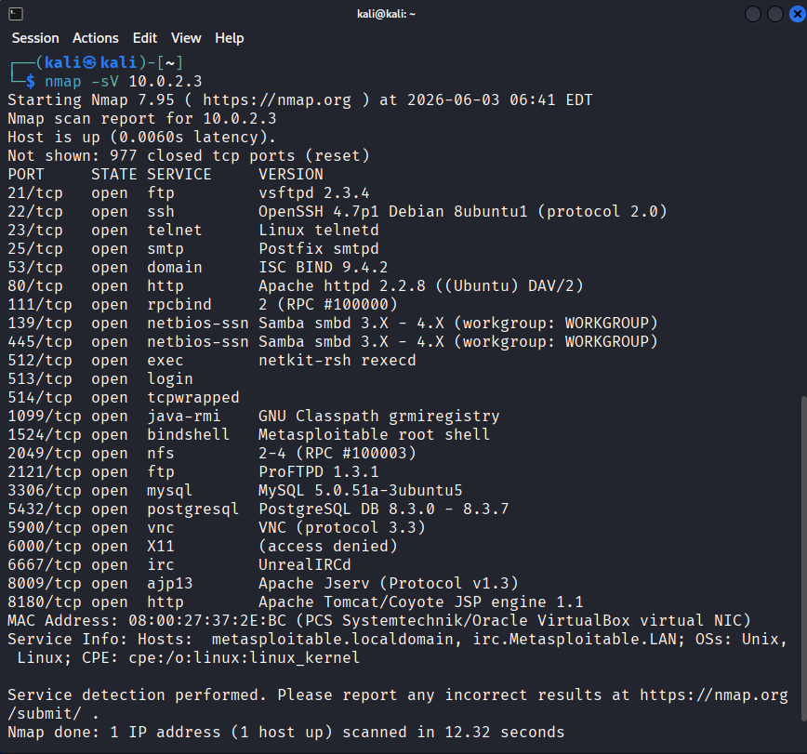
Figure 2: nmap scan found 23 open ports on the target
Step 3: A connection was launched using port 22
Then port 22 of the target machine was targeted to establish a connection between Kali Linux and Metasploitable using a remote SSH connection with the target’s username and IP address. This was done by running the command using the command:
“ssh -o HostKeyAlgorithms=+ssh-rsa -o PubkeyAcceptedAlgorithms=+ssh-rsa msfadmin@10.0.2.3”
The additional flag ‘-o PubkeyAcceptedAlgorithms=+ssh-rsa’ was used because the version of Metasploitable is old; in the latest version, this can be avoided.
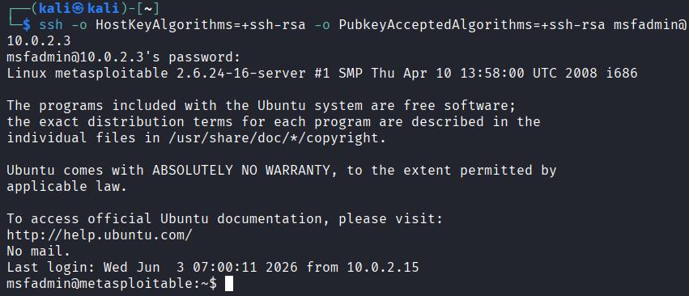
Figure 3 : SSH connection established with metasploitable
Step 4: Creating files containing credentials
The following commands, “cat /etc/passwd > passwd.txt” and “sudo cat /etc/shadow > shadow.txt”, were run to create files, where the former contains usernames and the latter contains hashed passwords, which is an encrypted format for storing passwords.
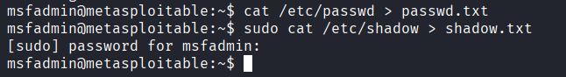
Figure 4: Passwd and shadow files extracted from the target
Step 5: Transferring the files to Kali
A separate terminal was opened on Kali Linux, and the files recently saved in the target machine were copied to Kali by running the commands below.
“scp -o HostKeyAlgorithms=+ssh-rsa msfadmin@10.0.2.3:/home/msfadmin/passwd.txt .”
“scp -o HostKeyAlgorithms=+ssh-rsa msfadmin@10.0.2.3:/home/msfadmin/shadow.txt .”
And the target machine’s password was entered.
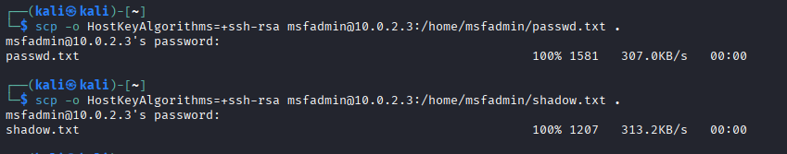
Figure 5: Files were transferred to Kali
Step 6: Merging files
By running the command “unshadow passwd.txt shadow.txt > hashes.txt”, the files passwd.txt and shadow.txt were merged. This format is necessary for the tool John the Ripper for cracking passwords.
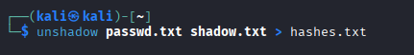
Figure 6: Merging files
Step 7: Cracking Passwords
The command “john --wordlist=/usr/share/wordlists/rockyou.txt hashes.txt” was run, which compares the combination of passwords inside the RockYou wordlist software with the passwords stored inside the merged file, i.e., hashes.txt, and reveals the cracked passwords.
In case you are unsure if the wordlist is pre-installed or not, run the command “ls /usr/share/wordlists/" before running John the Ripper. If the file RockYou does not exist, you can install it by running “sudo apt install wordlists” and unzip it by “sudo gzip -d /usr/share/wordlists/rockyou.txt.gz”.
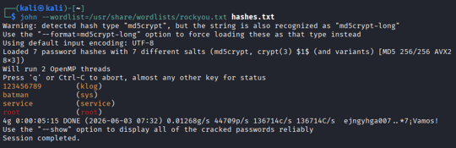
Figure 7: Launching John the Ripper tool
Step 8: Viewing results
Lastly, run the command “john --show hashes.txt” to see results, the passwords cracked, and left.
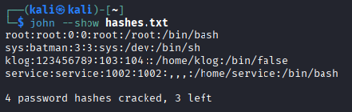
Figure 8: The tool cracked 4 passwords, including root
FINDINGS
Nmap scan on the target machine revealed 23 open ports, such as SSH on port 22, FTP on port 21, etc., which demonstrated a large attack surface and a lack of security of the system. Furthermore, the findings revealed that, by using John the Ripper, 7 accounts were discovered, and the password for 4 accounts was determined within 5 minutes. These passwords were discovered as they aligned with the existing wordlist dictionary. The cracked credentials were: klog: 123456789, sys: batman, service: service, and root: root, the most privileged account on any Linux system, meaning an attacker can gain complete control over the system.
LESSONS:
- Open ports are entry points for attackers, and in real organizations, these ports should be closed to offer the least privilege.
- Strong passwords are critical for organizations, and strict policies should be made regarding the strength of passwords.
- Regular password audits should be conducted by security teams by using tools like John the Ripper to detect weak credentials before attackers.

